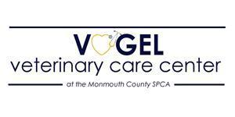
The Vogel Spay Neuter Clinic at the Vogel Veterinary Care Center, MCSPCA, is seeking an experienced veterinary technician to join our team. The Clinic is a dynamic fast-paced environment, where efficiency is key to providing safe surgical procedures and quality peri-operative care to dozens of animals each day. We are a well-established facility in beautiful Monmouth County, NJ, that serves a diverse client base, including MCSPCA shelter animals. By making spay and neuter more accessible for all pet owners, we hope to reduce pet overpopulation, animal cruelty and neglect.

We are a forward-thinking clinic with modern equipment, including new anesthesia machines, advanced patient monitoring devices, and suction and cautery equipment. The candidate will work with a team of highly skilled veterinary technicians and assistants in providing the highest-quality care possible.

The Vogel Spay Neuter Clinic offers very competitive compensation, comprehensive benefits for full-time employees including 90% employer funded health insurance premiums, generous paid time off, and access to a retirement plan option. Additionally, our employees are eligible for the Public Service Loan Forgiveness Program after 10 years of employment.

Requirements:

- Three years in the veterinary field with at least one year of surgical/anesthesia experience
- Certification/licensure is preferred.

*This job description is subject to change based on the needs of the organization and discretion of the medical director.

Please contact Gina Lawson, Clinic Manager (gina@vogelvet.org) for more information or to apply.

