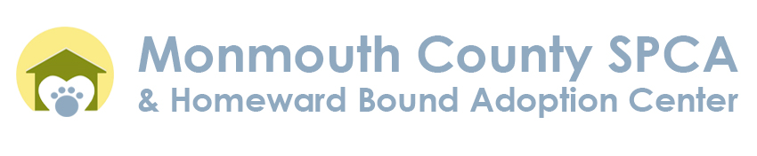

Job Description
Animal Control Officer (ACO)

Summary
The work of the ACO involves patrolling assigned areas of the county to enforce Animal Control Ordinances and related laws, rules and regulations. ACOs must travel to various municipalities to pick up animals in distress, strays, injured animals and dead animals, as assigned. The ACO enforces county and state animal regulations, including but not limited to cruelty to animals, dangerous/vicious animals and animal bites as they pertain to dogs, cats, livestock and fowl:
Qualifications
- Purpose and methods of animal control program (experience)
- Effective methods of controlling and containment of domestic animals
- Perform animal control duties efficiently
- Handle animals safely and effectively
- Deal courteously with the public
- Operate vehicle safely
- One year of progressive responsible experience in working force with animals
- 4 years Driver's License
- Must be a resident of Monmouth County
Physical Demands
Work is regularly active with periods of heavy exertion, in the field setting and outside in varying weather conditions. Position requires walking or standing for long periods; lifting and carrying up to 100 lbs on a regular basis; climbing stairs and bending, kneeling, crouching and crawling; reaching, holding, grasping and turning objects.
Patrols assigned county areas contain and pick-up stray, sick/injured, feral, and/or unwanted and captured domestic animals, transporting them to appropriate destination. Perform emergency animal rescue service, emergency night calls service, and animal first aid when required. Employee is subject to work beyond normal scheduled hours, including weekends and holidays, as required. Serves and responds to court and animal control board summonses as necessary and represents county at court and animal control board hearing. Issues warnings/citations to animal owners found in violation of animal regulations. Respond to and investigates complaints from citizens concerning domestic animals.
Responsibilities
- Prepare and maintain necessary reports and records
- ACOs must be in proper uniform as issued by the at all times while on duty
- Have in possession: ID Card, NJ Driver's License, Badge, and ACO Certification Card
- Complete any assignments given by municipality
- Maintain written record of all responses to assignments by recording all calls and cases on daily log sheet
- Complete various reports as required, such as Stray Pick-Up Report, Cruelty Report, Owner Release, Trap Rental Agreements, etc.
- Office staff should be informed of your location in the event an emergency needs attention so they can dispatch the nearest ACO
- Trapping: Must collect property deposit for the delivery of traps and record of deposit on trap receipt, Respond to calls for the delivery or setting of traps to a private residence or public area. Indicate when paid in cash or include check number on receipt. If animal in trap dies report to Executive Director/SPCA! No trapping in bad weather (rain, snow, heat wave). Animal should be released about 2 miles away from the previous address
- Cruelty calls during the night should be informed by Supervisor to assist on the scene
- Abandoned houses should not be entered unless Police on scene
- Keep your truck in good and clean operating condition
(YOU ARE RESPONSIBLE FOR THE CONDITION OF THE VEHICLE)
- Maintaining equipment needed in the capture, containment, transport, and comfort of animals being transported
- Ensure proper equipment such as snare poles, leashes, bolt cutters, cameras, extra animal carriers, traps (cat, squirrel, raccoon, bird)
- Maintain vehicle log for the proper maintenance of oil changes (every 3000 miles) and brakes (every 5000 miles)
- Notify General Manager/Supervisor of maintenance needed and make arrangements to have vehicle taken out of service for repair. Vehicles from offices other than facility will be taken to for certain repairs at the discretion. Arrangements must be made in advance for the pickup of an exchange vehicle
- ACOs are subject to emergency calls made after the shelter is closed, and also on overnights and weekend days
- ACOs are placed on a rotating schedule for emergency calls that could be different for each office. Emergency calls are carried out from the following morning when the opens for business
- If the ACO responds to a call and determines that emergency medical assistance is needed for an animal, the injured animal must be transported to the animal hospital used for that office.This would be considered a second call to transport the animal to the hospital. A copy of the emergency call should be made having the same TAG Number and the emergency will be marked in order to be paid for both calls
- It is the ACOs responsibility to keep record of calls made during ea.ch pay period
- If the ACO notices a discrepancy for payment he/she must bring it to the General Manager's attention upon receiving their pay check or notice of direct deposit

