 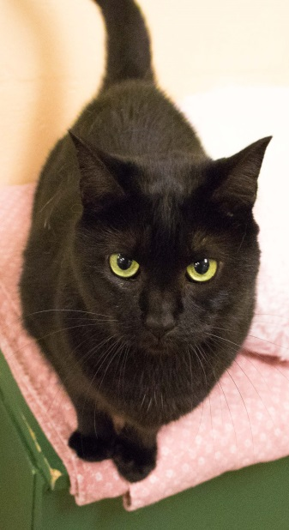

**I am approximately 6 years old on 8/19/17**

**I’ve been at the shelter since 7/6/17**

**I am a Male / Female Spayed / Neutered**

My story: Were you looking for an absolutely amazing pair of felines? If you were, you can stop looking!!!!

I came to the MCSPCA with my brother, and bff, Blondie. Our owner could no longer care for us because she moved into an assisted living facility, so her friend brought us to the shelter to find a new home. We know our owner had no other choice-she loved us very much. Blondie and I also love each other very much and we are looking to be adopted together.

I’m a really sweet boy. I admit, Blondie is the more outgoing of the 2 of us, so you can’t help but become enamored with him in 10 seconds flat. If you just give me a little time to settle in though, you’ll see that I’m just as wonderful to be around. I love to be petted. I love to be cuddled. And I’d love nothing more than to curl up beside you (and Blondie) on the couch and watch your favorite show on TV!

Everyone knows that the only thing better than 1 amazing kitty cat is 2 of them! So make your dreams come true and take us home today! ☺

**MooMoo**